24 — Навигация в приложении от 27.09.26 9ИС-360 Чайкин А.

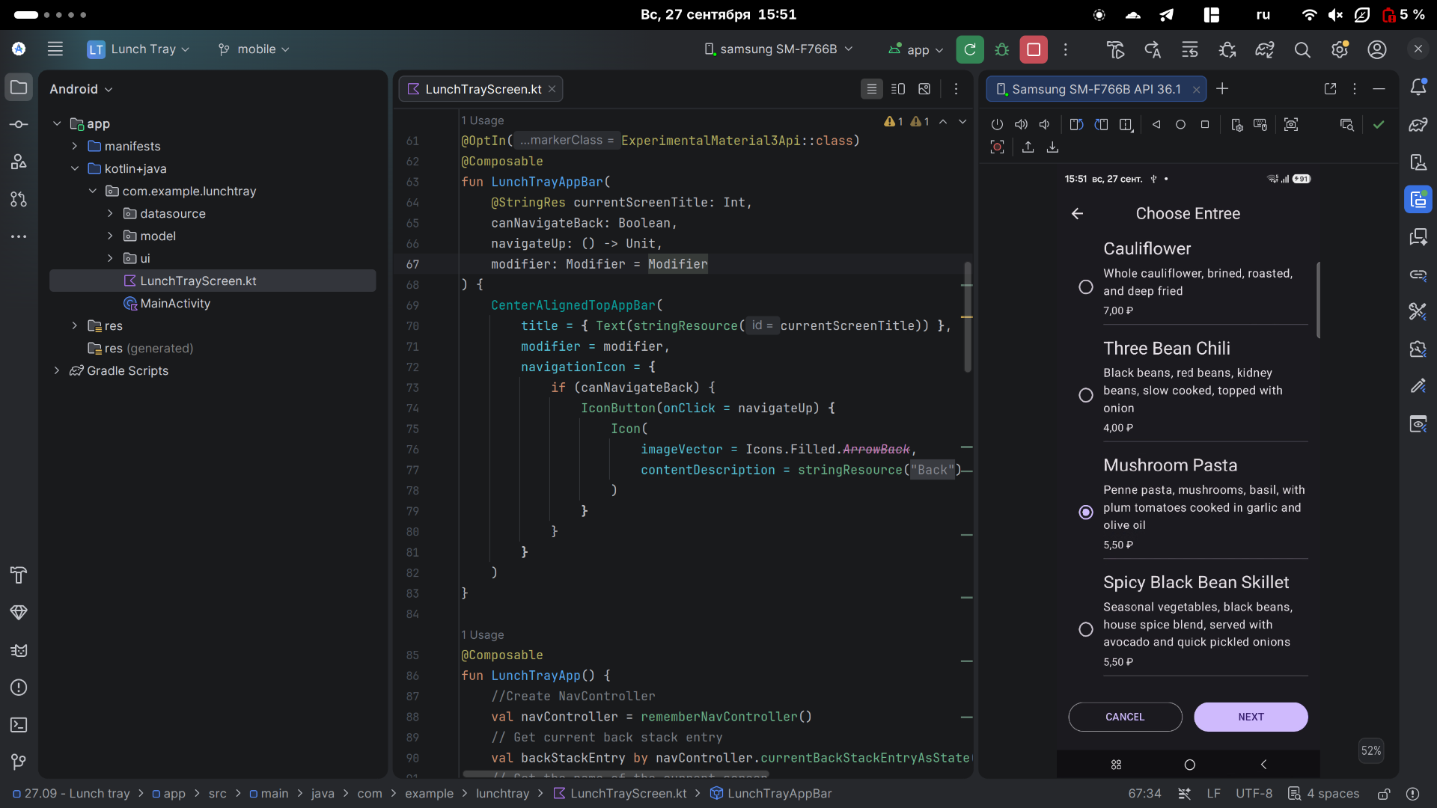
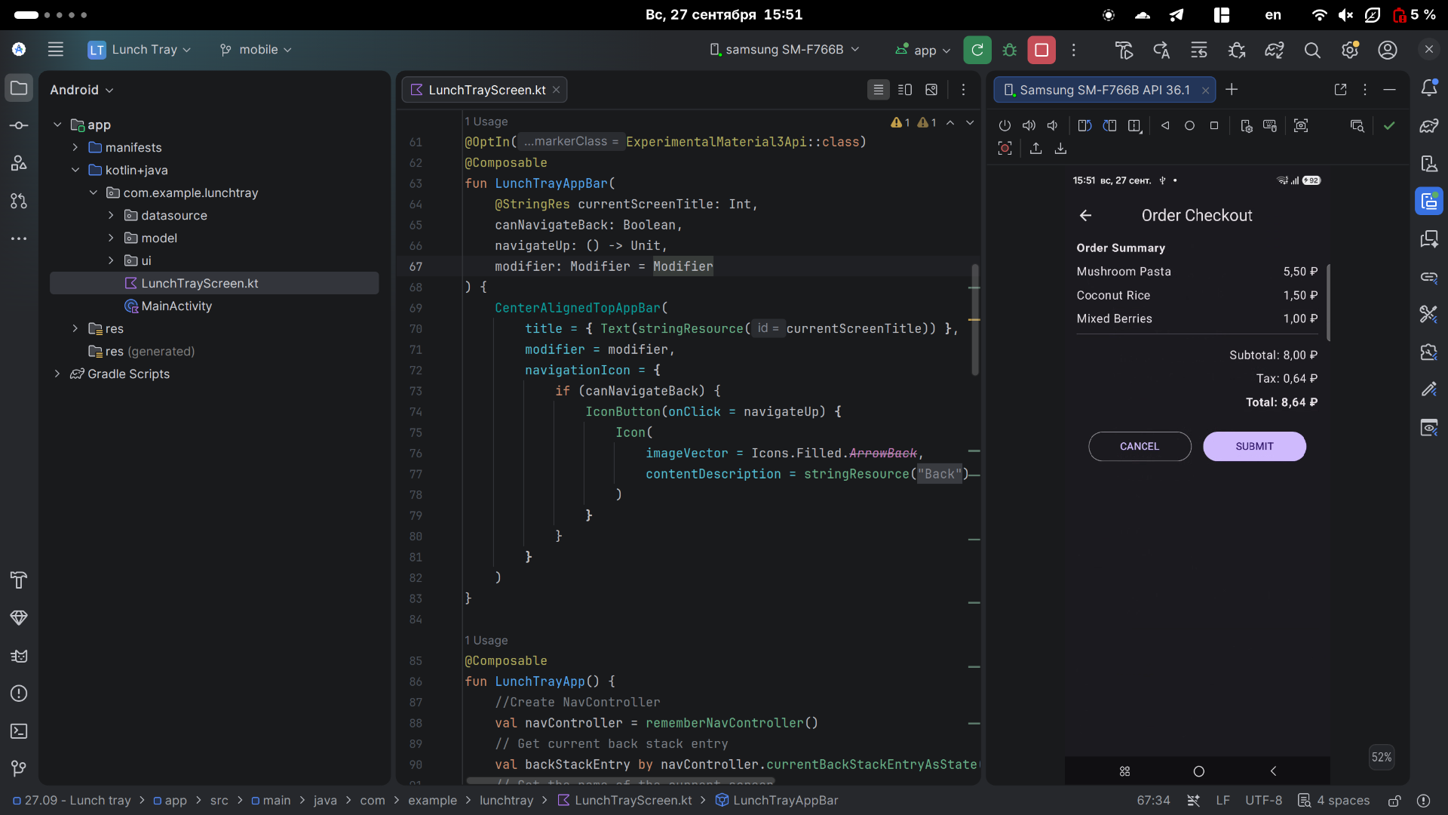
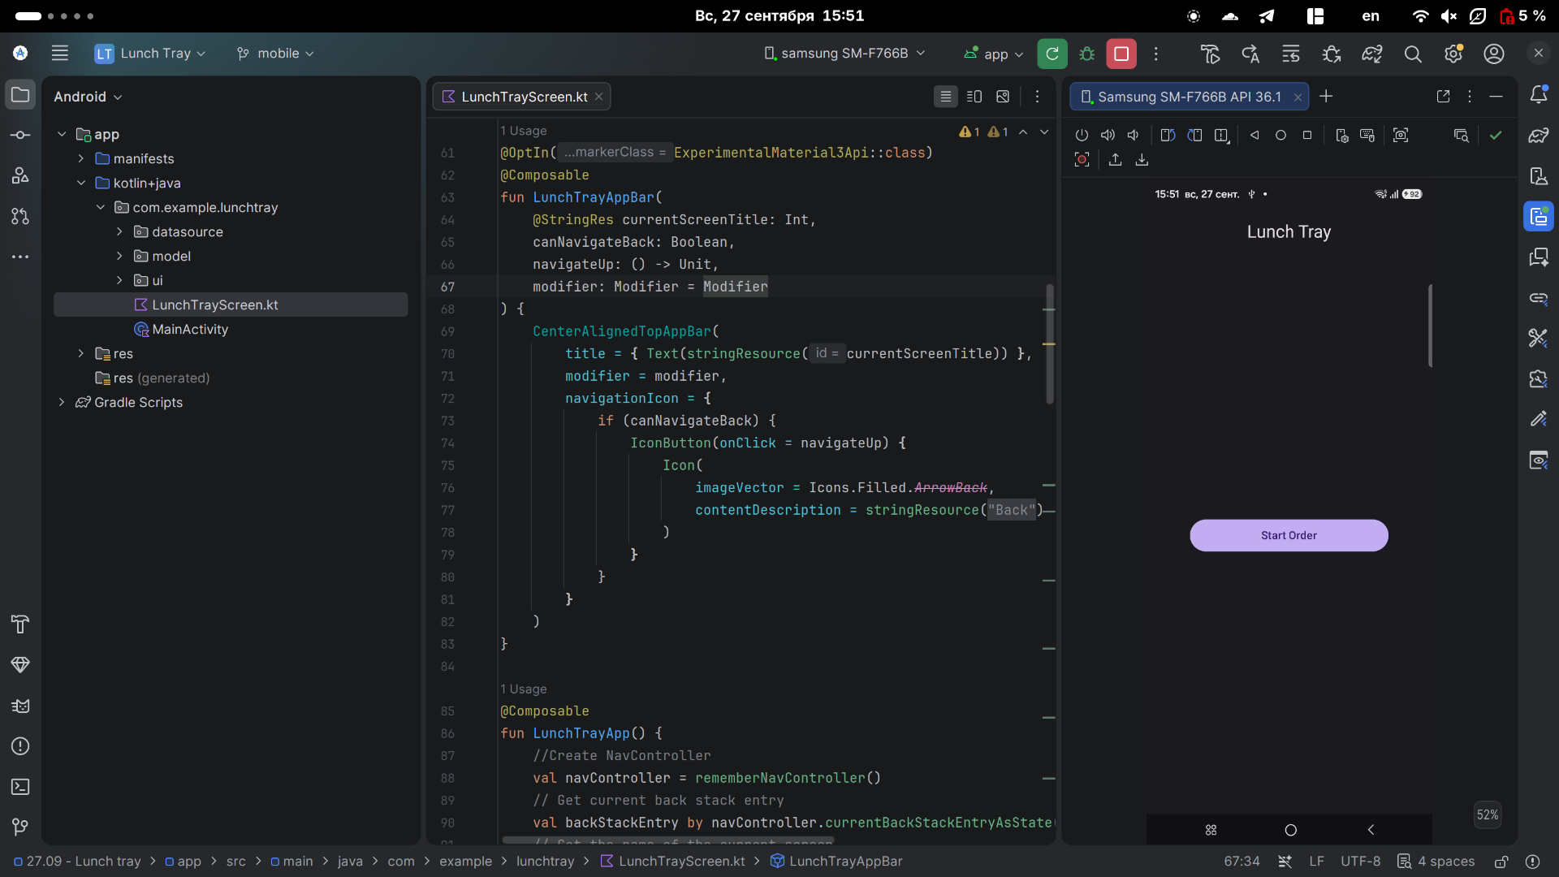
LunchTrayScreen.kt

package com.example.lunchtray
import androidx.annotation.StringRes
import androidx.compose.foundation.layout.fillMaxSize
import androidx.compose.foundation.layout.padding
import androidx.compose.foundation.rememberScrollState
import androidx.compose.foundation.verticalScroll
import androidx.compose.material.icons.Icons
import androidx.compose.material.icons.filled.ArrowBack
import androidx.compose.material3.CenterAlignedTopAppBar
import androidx.compose.material3.ExperimentalMaterial3Api
import androidx.compose.material3.Icon
import androidx.compose.material3.IconButton
import androidx.compose.material3.Scaffold
import androidx.compose.material3.Text
import androidx.compose.runtime.Composable
import androidx.compose.runtime.collectAsState
import androidx.compose.runtime.getValue
import androidx.compose.ui.Modifier
import androidx.compose.ui.res.dimensionResource
import androidx.compose.ui.res.stringResource
import androidx.lifecycle.viewmodel.compose.viewModel
import androidx.navigation.compose.NavHost
import androidx.navigation.compose.composable
import androidx.navigation.compose.currentBackStackEntryAsState
import androidx.navigation.compose.rememberNavController
import com.example.lunchtray.datasource.DataSource
import com.example.lunchtray.ui.AccompanimentMenuScreen
import com.example.lunchtray.ui.CheckoutScreen
import com.example.lunchtray.ui.EntreeMenuScreen
import com.example.lunchtray.ui.OrderViewModel
import com.example.lunchtray.ui.SideDishMenuScreen
import com.example.lunchtray.ui.StartOrderScreen
enum class LunchTrayScreen(@StringRes val title: Int) {
Start(title = R.string.app_name),
Entree(title = R.string.choose_entree),
SideDish(title = R.string.choose_side_dish),
Accompaniment(title = R.string.choose_accompaniment),
Checkout(title = R.string.order_checkout)
}
/**
* Composable that displays the topBar and displays back button if back navigation is possible.
*/
@OptIn(ExperimentalMaterial3Api::class)
@Composable
fun LunchTrayAppBar(
@StringRes currentScreenTitle: Int,
canNavigateBack: Boolean,
navigateUp: () -> Unit,
modifier: Modifier = Modifier
) {
CenterAlignedTopAppBar(
title = { Text(stringResource(currentScreenTitle)) },
modifier = modifier,
navigationIcon = {
if (canNavigateBack) {
IconButton(onClick = navigateUp) {
Icon(
imageVector = Icons.Filled.ArrowBack,
contentDescription = stringResource(R.string.back_button)
)
}
}
}
)
}
@Composable
fun LunchTrayApp() {
//Create NavController
val navController = rememberNavController()
// Get current back stack entry
val backStackEntry by navController.currentBackStackEntryAsState()
// Get the name of the current screen
val currentScreen = LunchTrayScreen.valueOf(
backStackEntry?.destination?.route ?: LunchTrayScreen.Start.name
)
// Create ViewModel
val viewModel: OrderViewModel = viewModel()
Scaffold(
topBar = {
LunchTrayAppBar(
currentScreenTitle = currentScreen.title,
canNavigateBack = navController.previousBackStackEntry != null,
navigateUp = { navController.navigateUp() }
)
}
) { innerPadding ->
val uiState by viewModel.uiState.collectAsState()
NavHost(
navController = navController,
startDestination = LunchTrayScreen.Start.name,
modifier = Modifier.padding(innerPadding)
) {
composable(route = LunchTrayScreen.Start.name) {
StartOrderScreen(
onStartOrderButtonClicked = {
navController.navigate(LunchTrayScreen.Entree.name)
},
modifier = Modifier
.fillMaxSize()
)
}
composable(route = LunchTrayScreen.Entree.name) {
EntreeMenuScreen(
options = DataSource.entreeMenuItems,
onCancelButtonClicked = {
viewModel.resetOrder()
navController.popBackStack(LunchTrayScreen.Start.name, inclusive = false)
},
onNextButtonClicked = {
navController.navigate(LunchTrayScreen.SideDish.name)
},
onSelectionChanged = { item ->
viewModel.updateEntree(item)
},
modifier = Modifier
.verticalScroll(rememberScrollState())
)
}
composable(route = LunchTrayScreen.SideDish.name) {
SideDishMenuScreen(
options = DataSource.sideDishMenuItems,
onCancelButtonClicked = {
viewModel.resetOrder()
navController.popBackStack(LunchTrayScreen.Start.name, inclusive = false)
},
onNextButtonClicked = {
navController.navigate(LunchTrayScreen.Accompaniment.name)
},
onSelectionChanged = { item ->
viewModel.updateSideDish(item)
},
modifier = Modifier
.verticalScroll(rememberScrollState())
)
}
composable(route = LunchTrayScreen.Accompaniment.name) {
AccompanimentMenuScreen(
options = DataSource.accompanimentMenuItems,
onCancelButtonClicked = {
viewModel.resetOrder()
navController.popBackStack(LunchTrayScreen.Start.name, inclusive = false)
},
onNextButtonClicked = {
navController.navigate(LunchTrayScreen.Checkout.name)
},
onSelectionChanged = { item ->
viewModel.updateAccompaniment(item)
},
modifier = Modifier
.verticalScroll(rememberScrollState())
)
}
composable(route = LunchTrayScreen.Checkout.name) {
CheckoutScreen(
orderUiState = uiState,
onCancelButtonClicked = {
viewModel.resetOrder()
navController.popBackStack(LunchTrayScreen.Start.name, inclusive = false)
},
onNextButtonClicked = {
viewModel.resetOrder()
navController.popBackStack(LunchTrayScreen.Start.name, inclusive = false)
},
modifier = Modifier
.verticalScroll(rememberScrollState())
.padding(
start = dimensionResource(R.dimen.padding_medium),
end = dimensionResource(R.dimen.padding_medium),
)
)
}
}
}
}

